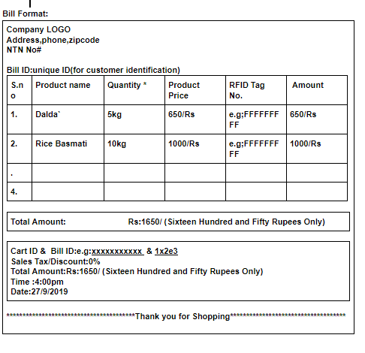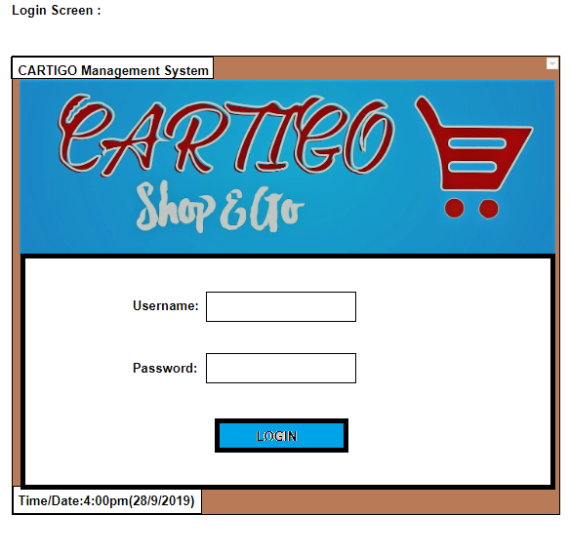

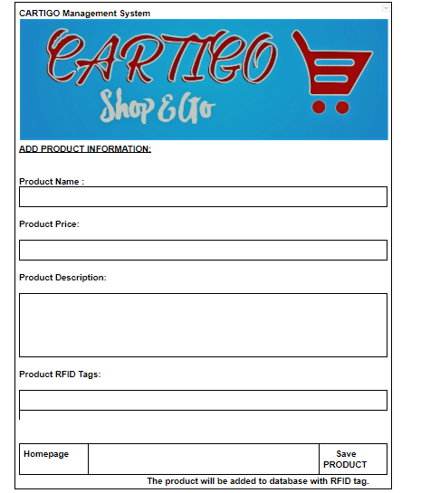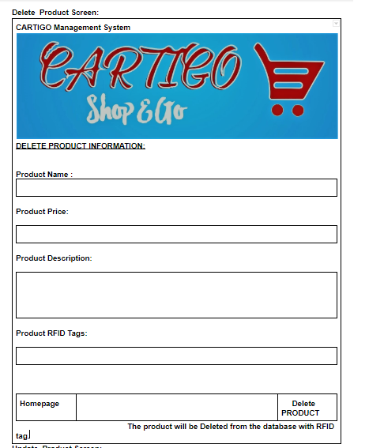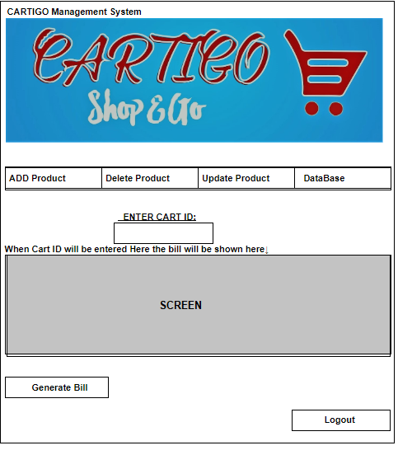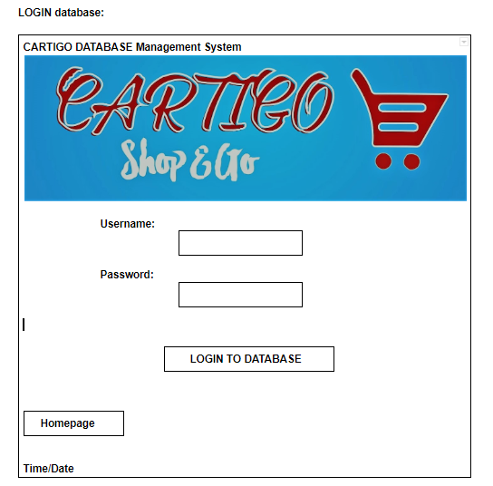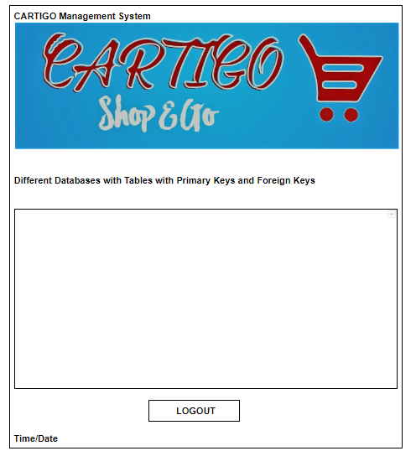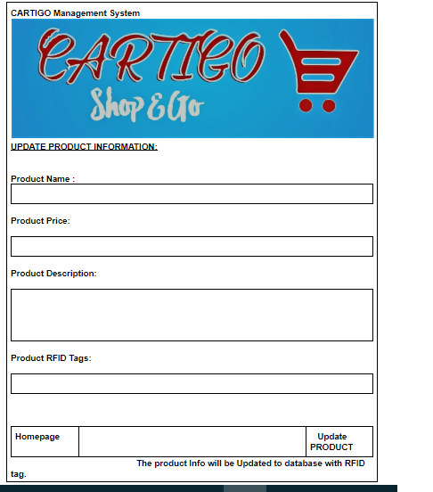

**Database Entities;**

1. **Product Name**
2. **Product price**
3. **Quantity**
4. **RFID tags**
5. **Cart_ID**
6. **Bill_ID(Unique id)**
7. **Total amount:**
8. **Total amount( in words):**
9. **Time**
10. **Date**

**Table:**

1. **Product name and Product prices with RFID tags integrated**
2. **Cart ID, Bill ID(Unique ID) and Total Amount,Time ,Date**
3. **Order Table :Bill ID and Cart ID Total Amount, Order time and Date**
4. **Inventory Management System(Sales report)**

**Trolly unit:**

**1)Arduino board**

**2)ESP8266 WIFI module**

**3)RFID reader**

**4)LCD screen**

**\*serial number**

**\*Product name**

**\*Product price**

**\*Total Amount**

**4)Remove button**

**5)Reset button**

**6)send data button**